Lab #1 Lab Report

Intro to ModelSim and QtSpim

William Ah Tou

April 10, 2016

ECEGR 2220

Console result from QtSpim and swap.s program:

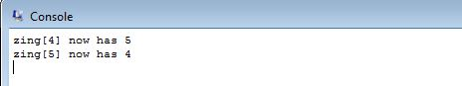

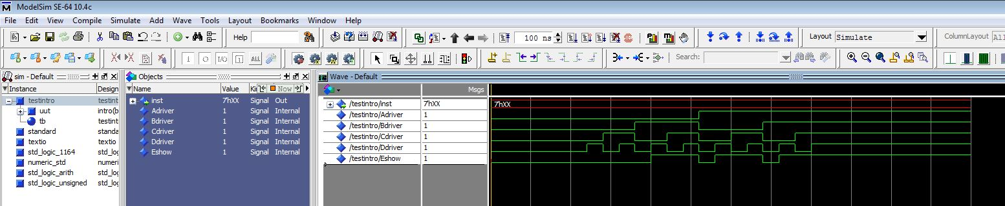Simulation result from ModelSim: